New Dis-Eur-England-Kent-Clactonian-Flat Chopper-424,000 BP-374,000 BP

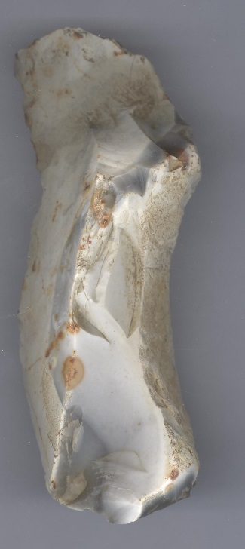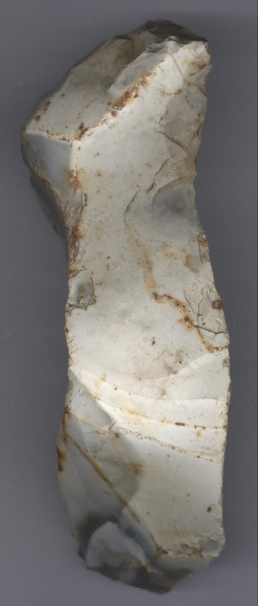

Figs. 1-2. England-Kent-Clactonian-Chopper-424,000 BP-374,000 BP

Fig. 3. A reconstruction of *Homo erectus* at the Westfälisches Landesmuseum, Herne, Germany, in a 2006 exhibition. From https://upload.wikimedia.org/wikipedia/commons/thumb/c/cb/Homo_erectus_new.JPG/200px-Homo_erectus_new.JPG

**Formal Label:** England-Kent-Clactonian-Chopper-424,000 BP-374,000 BP

**Display Description:**

Clactonian refers to the flint tools found in a paleo-channel at Clacton-on-Sea in Essex, England, in 1911 (Warren 1922). The present chopper was found near the destroyed flint quarries of Barnfield Pit and Rickson's Pit, Swanscombe area, Kent County, England (Darvill, 30 Jan 2017; Tester 1984). This chopper was made by *Homo erectus* in the early Hoxnian Interglacial, Marine Isotope Stage 11, 424,000 BP-374,000 BP (Lisiecki and Raymo 2005; Stringer 2006). It was made on a 2 inch, flat flint nodule and then flaked with two bulbs of percussion to make a distal point. Then the proximal end was flaked with two bulbs of percussion to shape it to fit the hand. There was no thinning to reduce its weight or to produce lateral edges. It has a simple bilateral symmetry. The distal end has had bifacial working to form a robust point. The result was a crude cordiform or heart-shaped chopper. Remnants of an ancient patinated cortex and the typical brown iron-oxide staining of the Swanscombe area are evident on both sides.

**Accession Number:**

**LC Classification:** GN772.22.G7

**Date or Time Horizon:** 424,000 BP-374,000 BP.

**Geographical Area:** Kent County near Swanscombe.

**Map, GPS Coordinates:** 51.44107 0.33694; 40° 26' 46" N 79° 58' 56" W

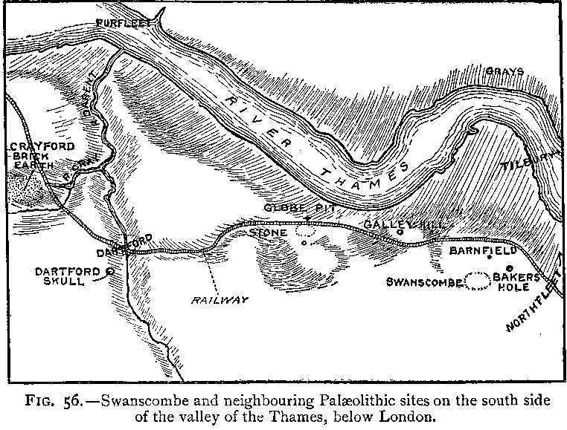

Fig. 4. “Swanscombe and neigbouring Palaeolithic sites on the south side of the valley of the Thames, below London,” (Keith 1916).’

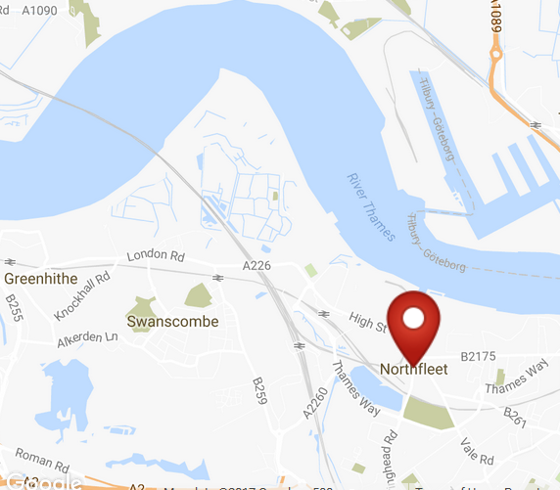

Fig. 5. Map of Northfleet. From http://latitude.to/img/latitude-logo.svg.

**Cultural Affiliation:** Lower Paleolithic, Clactonian.

**Medium:** flint.

**Dimensions:   
Weight:**

**Provenance: found in the** Northfleet Area east of Swanscombe.

**Condition:** original, with ancient patination and sheen.

**Discussion:**

Clues to the nature of the environment in which this Clactonian tool was used are provided by faunal remains from the gravel at Swanscombe, which includes bones of Pleistocene animals, including the straight-tusked elephant *(Palaeoloxodon antiquus*) (Glass 2016) and the giant hippopotamus, (Hippopotamus amphibius) (Schreve 2009**;** Tester 1984), indicating a temperate climate in a fertile valley bordered by woodlands.

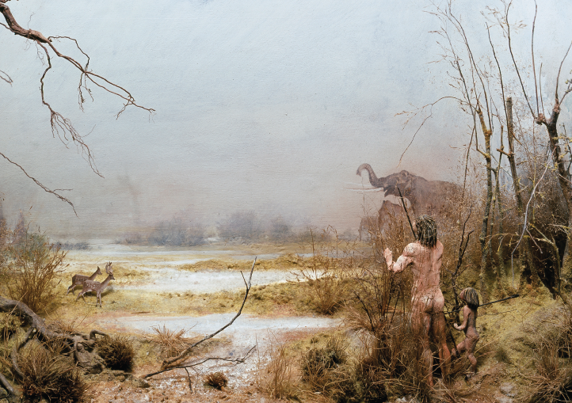

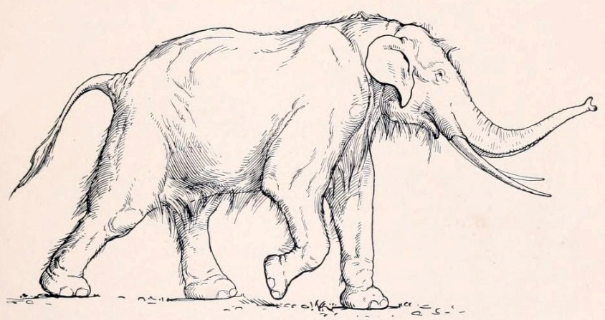 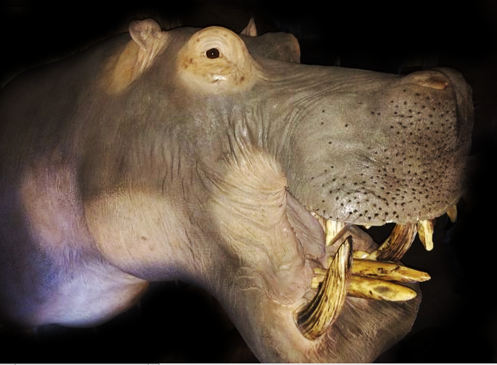

Fig. 4. Reconstruction of the Ebbsfleet Valley, 410,000 BC.

From <http://library.thehumanjourney.net/2732/1.hassmallThumbnailVersion/1-Prelims.pdf>. Cover illustration © Natural History Museum

Fig. 5. *Paleoloxidon antiquus* (lived 781,000–50,000 BP) with a height of 3.90 m (12 ft). From http://upload.wikimedia.org/wikipedia/commons/c/c0/Elephas_antiquus_Straight_tusked_elephant.jpg

Fig. 6. Hippopotamus amphibious, taxidermy showing replica teeth, from https://assets.catawiki.nl/.jpg

There is also a controversy are these Clactonian choppers part of the more advanced Acheulian bifacial hand axe industry? In 2004 an excavation of a butchered *Paleoloxidon antiquus* at the Southfleet Road site “High Speed 1” in Kent recovered Clactonian flint tools including choppers but no Acheulian hand axes, which would have been more useful, with their bilateral sharp edges, than a chopper, with only a sharp distal end to dismember *Paleoloxidon antiquus*. This is considered strong evidence that those who butchered the *Paleoloxidon antiquus* did not comprehend Acheulian flaking technology (see Wenban-Smith 2013).

**References:**

Conway, Bernard, John McNabb and Nick Ashton, eds. 1996. *Excavations at Barnfield Pit,* *Swanscombe, 1968-72*; illustrations by Phil Dean. London: Dept. of Prehistoric and Romano-British Antiquities.

Glass, Helen. 2004. “Stone Age elephant remains found,” BBC News, 19 June. <http://news.bbc.co.uk/2/hi/uk_news/england/kent/3821527.stm>. Retrieved 1 Feb 2017.

Keith, Arthur. 1915. *The Antiquity of Man*. London.

Lisiecki, Lorraine E. and Maureen E. Raymo. 2005. [*"A Pliocene-Pleistocene stack of 57 globally distributed benthic δ18O records"*](http://www.lorraine-lisiecki.com/LR04_MISboundaries.txt). <http://www.lorraine-lisiecki.com/LR04_MISboundaries.txt>. Retrieved 1 Feb 2017.

## McNabb, John. 2007. *The British Lower Palaeolithic: stones in contention*. London, New York: Routledge.

# Schreve, Danielle C. 2009. “A new record of Pleistocene hippopotamus from River Severn terrace deposits, Gloucester, UK—palaeoenvironmental setting and stratigraphical significance,” *Proceedings of the Geologists' Association*, 120 (1): 58–64.

Stringer, Chris. 2006. Homo Britannicus: The incredible story of human life in Britain. It was made on a thin, flat flint nodule and then flaked with two bulbs of percussion to a cordiform or heart-shape. There was no thinning to reduce its weight or to produce lateral edges. It has a simple bilateral symmetry. The distal end has had bifacial working to form a robust point. The proximal end has to bulbs of percussion to shape it to fit the hand. The tool has the remnants of an ancient patinated cortex on both sides. The typical brown iron oxide stating of the Swanscombe area is evident on both sides.

Tester, P. J. (1984). "Clactonian Flints from Rickson's Pit, Swanscombe," Archaeologia Cantiana, Kent Archaeological Society. Retrieved 1 Feb 2017.

Warren, S. H. 1922. “The Mesvinian Industry of Clacton-on-Sea,” Proceedings of the Prehistoric Society of East Anglia, 3: 597-602.

#### 

#### Wenban-Smith, Francis. 2013. The Ebbsfleet Elephant: Excavations at Southfleet Road, Swanscombe in advance of High Speed 1, 2003-4. Oxford Archaeology Monograph. Series: 20. Oxford: Oxford Archaeology Press.